Astraeus Analytics Data Collector System Design Specification
Author | Revision Number | Date
architect | 1.0 | November 13, 2012

Astraeus Analytics Data Collector System Design Specification 1
System Design Specification 4
1. Introduction 4
1.1 Purpose 4
1.2 Glossary 5
2. Logical Architecture 6
2.1 JavaScript Library 6
2.2 Data Collector REST service 6
2.3 Cassandra Cluster 6
2.4 Storm Topology for Real Time Access 7
2.5 Tracking Info Migrator 7
2.6 Hadoop Cluster 7
2.7 Zookeeper 7
3. Modular Architecture 7
3.1 Astraeus Analytics JavaScript Module 7
3.2 Astraeus Analytics Real-time Server Module Architecture 7
3.3 Astraeus Analytics Batch Server Module Architecture 7
3.4 Astraeus Analytics Admin Module 7
4. Data Model 8
4.1 Tracks Data Model 8
4.2 Schema Data Model 8
5. Process Architecture 9
5.1 4.4.1 Login: 9
5.2 4.4.2 Logout: 9
5.3 4.4.3 View Help 9
5.4 4.4.4 View Admin Tool Homepage 9
5.5 4.4.5 View Registered Schema, 4.4.6 Register Schema Manually, 4.4.7 Import Schema, 4.4.8 Modify Schema, 4.4.9 Remove Schema 9
5.6 4.4.10 View Developer Documentation 9
5.7 4.4.12 View Application Settings, 4.4.13 Modify Application Settings 10
5.8 4.4.15 Publish Real-time Analytics Data 10
5.8.1 Real Time Analytics 10
5.9 4.4.16 Publish Batch Analytics Data 10
5.9.1 Batch Computations 10
5.10 4.4.18 Authenticate Analytics Request 11
5.11 4.4.19 Collect Basic Analytics Data, 4.4.17 Receive Analytics Request, 4.4.14 Send Analytics Request [external] 11
5.12 4.4.20 Store Request Data 11
5.13 4.4.21 Return Response to Caller 11
5.14 4.4.22 Archive Real-time Data 11
5.15 4.4.23 Localize GUI 12
5.16 4.4.24 Perform Logging 12
5.17 4.4.25 Perform Auditing 12
6. Security 13
6.1 Authentication 13
6.2 Authorization 13
6.3 Audit 13
6.4 Data Privacy 13
6.5 Data Integrity 13
7. Deployment and Development Concerns 13
7.1 Logical Deployment 13
7.2 Physical Deployment 15
7.2.1 Metrics Requirements 15
7.2.2 Page Performance Requirements 15
7.2.3 Hardware 15
7.2.4 Software 15
7.2.5 Database 15
7.2.6 Application Server 15
7.2.7 Operation Systems 16
7.2.8 Prototype conversion 16
7.3 User Interface Implementation 16
7.4 Transaction Management 16
7.5 Configuration 16
7.6 Logging 16
7.7 Concurrency and Thread Safety 16
7.8 Exception Handling 16

System Design Specification

Introduction

Purpose
The client for this project, Astraeus, has decided to build a super high-scale data collection and analytics platform. This new Analytics Data Collector platform will collect usage and behavior analytics data for entertainment applications. The primary functions of the new application will be to capture, store and manipulate big data. “Big data” is defined as real-time data that will be accumulated all the time so the database will continue to grow bigger.

The new Analytics Data Collector platform will be made up of four parts:

- Java based data collection server application that collects data (either through REST APIs or requests to gif images).
- A data repository for storing and querying the data. This data repository will include two different types of data stores:
  - A real-time data store where analytics information will be collected in real-time and stored for 30 days.
  - A long term data store for longer range processing and analytics. After 30 days, real-time data will be moved to this long term data store.
- An admin tool that allows for managing the application and for owners of client applications to register their custom data schemas.
- A JavaScript library to make it easy for developers to enable data collection in their applications.

The data collection process will begin when the user of an external application (which is configured to use the Analytics Data Collector platform) requests a page. When the page loads, it will include JavaScript within the page to send to the Analytics Data Collector server. This request will include information about the page and the user.

The Analytics Data Collector platform will receive the request from the external application and authenticate the calling application. Data from the request will then be stored to the real-time data store. When this process is complete, the Analytics Data Collector API will send a response back to the calling application to confirm if the request was successful or not.

The new data collector platform will need to handle a large volume of requests. It is expected to receive up to 10,000 requests per second initially. The system will be designed to scale horizontally to handle this amount of requests.

The data that is collected by the server application will be sent in the form of key-value pairs. The data model used will be flexible enough to support new data elements (key-value pairs). The owners of the client applications will use the admin tool to register their custom data schemas to map against the data they send to the Analytics Data Collector platform.

The JavaScript library will enable basic analytic data collection for a typical web application or website. The Application Developer will be able to add this basic analytics JavaScript code into their application and it will start sending data to be collected via the API.

The platform will also publish the collected analytics data for consumption by external reporting tools. Real-time data will be published to be consumed by Storm or a similar system that enables real-time (up to the minute or even second) calculations and analysis. Regular, non-real-time data will also be published for analysis by other external reporting tools that don’t require real-time analysis.

The Analytics Server Owner will also be able to use the admin tool to view and manage application settings.

Glossary
Acronym/Term | Description
REST | Representational State Transfer
HTTP | Hypertext Transmission Protocol
CQL | Cassandra Query Language
API | Application Programming Database
MVC | Model View Controller
AJAX | Asynchronous JavaScript with XML
RDBMS | Relational Database Management System
LDAP | Lightweight Directory Access Protocol
CRUD | Create Retrieve Update Delete
HDFS | Hadoop Distributed File System
URL | Unified Resource Locator
DNS | Domain Naming Service
RAM | Random Access Memory
OS | Operating System
track | A track is a piece of data analytics information sent from the client’s website to our system. It typically contains the user and her page visit information.

Logical Architecture
This section discusses the various logical blocks of the architecture. Note that logical blocks are not equivalent to modules; instead one module typically contains one or more of these logical blocks.

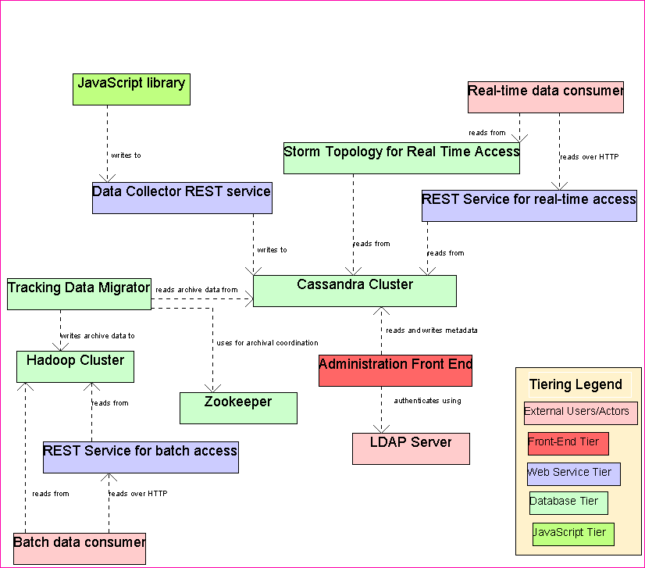

JavaScript Library
The JavaScript library is placed on the web pages of the client. It will capture the user’s activity on the web pages and sends track information (using AJAX requests) to the data collection REST service.

Data Collector REST service
This REST service will accept the track info sent from the JavaScript library. It will then save the track info to the Cassandra database.

Cassandra Cluster
This is the main database of the system. It will store track info and will also store the metadata for the clients. It is the real-time data store for the system. Cassandra is used here because it is highly suited to quick and small-sized reads and writes.

Storm Topology for Real Time Access
The Storm topology will simply be setup to read real-time data from the Storm cluster. The exact real-time analysis requirements are not known as of now.

Tracking Info Migrator
The Tracking Info Migrator is a scheduler job which will run at periodic intervals. It will load the tracking info which is older than a (configurable) age from the Cassandra cluster and move it to the Hadoop Cluster.

Hadoop Cluster
This is the archive database of the system. It will store track info older than a certain age. It is the long-term data store for the system. Hadoop is used here because by default it is suited for the write-once read-often usage. Also its data store format is more suited to large sequential reads rather than smaller random reads, which makes it suitable for batch analysis on large data.

Zookeeper
It is used for coordination logic in data migration.

NOTE: There is just one Cassandra cluster that stores the tracks (Astraeus Analytics Server Modules) and the metadata/configuration (Astraeus Analytics Admin Module). These are not separate clusters.

Modular Architecture
This section discusses the modules generated by this system architecture. Note that one module can encompass 1 or more logical blocks (see section 2).

Astraeus Analytics JavaScript Module
This module consists of the JavaScript library that will be designed to be placed on the web pages. It will send tracks to the collector REST service.

Astraeus Analytics Real-time Server Module Architecture
This module consists of the following:
- The collector REST service that collects the tracks
- The column families in the Cassandra cluster which store the track info.
- The REST service which will provide real-time access to the tracks data over HTTP.
- The Storm topology which will consume and analyze the real time data in Cassandra

Astraeus Analytics Batch Server Module Architecture
This module consists of the following:
- The Hadoop cluster to which the tracks data is migrated once it becomes old.
- The REST service which will provide batch access to the tracks data over HTTP.
- The data migrator which will periodically migrate the data from Cassandra to Hadoop.

Astraeus Analytics Admin Module
This module consists of the following:
- The column families in the Cassandra cluster which store the configuration related data such as registered clients and their information.
- The admin front-end used by clients and admins.

Data Model

Tracks Data Model
Cassandra’s databases design allows each row of a ColumnFamily (akin to a table in RDBMS) to contain different columns. This is useful in this system because there can be different keys for different tracks.
However each track will have some common data, which is defined as follows.
- client_id – The client to which this track belongs. It is taken from the client_metadata table when the track request is received.
- page_url – The URL of the page from which the track was sent. This doesn’t necessarily have to be the actual URL but it can be whatever the client decides to uniquely identify the page.
- page_referrer – The referrer to the current URL. This defaults to the HTTP referrer but again client can set it to whatever value it wishes.
- host_name – The host name of the client. This can be null but client can explicitly set it to some value. If null, then the host_name for the client is taken from the client table.
- visitor_id – The unique id of the visitor. It is generated on the client side.
- session_id – The unique id of the visitor’s current browsing session. It is generated on the client side.
- request_id – The id for the current track request. It must be globally unique and it is thus the primary key for the record. It is generated on the client side.
- timestamp – The current timestamp. This is ideally generated on the client side, but if not, then it is generated on server side.
Beyond these columns, the row in tracks table can have arbitrarily more number of columns. Each such column will correspond to the each key sent in the web service call (AnalyticsDataCollectorWebService.track method). All value of the column will be the corresponding index in the values array in the web service call. The values are saved in String format.

Schema Data Model
Each Client can have multiple schemas. Only one of them is considered the active schema at any moment. This will be used if the client does not send in a schema_id in the tracking web service call. Each schema is made up of many keys.
The client information will be saved in the client_metadata table. The columns defined for this table are as follows:
- client_id – The unique identifier of the client. If a particular company has many domains where web analytics tracking will be used, then they should be registered as separate clients.
- client_name – The name of the client
- client_api_key – The API access key for the client. This is sent in every tracking request. It is used to uniquely identify a client so it must be globally unique as well.
- default_host_name – The default host name of the client. It will be used if the host_name is not explicitly sent in the track request.
The client schema will be saved in the client_schema table. The columns defined for this table are as follows:
- schema_id – The id of the schema. This is the primary key.
- client_id – The id of the client for which this schema exists. This corresponds to client_id in client_metadata table.
- is_default – Whether this schema is the current default for this client. Only one of all schemas for a client can have this field set to true.
The client schema keys will be saved in the client_schema_keys table. The columns defined for this table are as follows:
- schema_id – The id of the schema for which this key is defined. This corresponds to schema_id in client_schema table.
- key – The key name. This should be unique for a given schema.
- key_description – The description of what the value under the key means.

Process Architecture

4.4.1 Login:
This process pertains to the login in the admin tool.
The login will be done using LDAP authentication. Spring LDAP should be used for LDAP API. Here is a simple example of authentication using Spring LDAP.
This logic will be performed in the AuthService.login method. The UserAuth object containing the user name and roles will be returned. This will be placed in the session by the front-end controller.

4.4.2 Logout:
The logout will be done by the front-end controller. It will most likely just invalidate the session and possibly call the Spring SecurityContextHolder.setAuthentication(null). This is up to module architect.

4.4.3 View Help
Help will most likely be static web pages.

4.4.4 View Admin Tool Homepage
The content of the home page(s) are not known now.
Different home pages will exist for different roles (Application Developers, Business Users, and the Analytics Server Owner)

4.4.5 View Registered Schema, 4.4.6 Register Schema Manually, 4.4.7 Import Schema, 4.4.8 Modify Schema, 4.4.9 Remove Schema
The schema related CRUD methods in the AnalyticsAdminService will be used to provide for the above processes. The mapping of process to method name is quite obvious.

4.4.10 View Developer Documentation
javadoc tool will be used to generate documentation from java source code. This will be needed at least for the REST web services.
jsdoc toolkit will be used to generate documentation from JavaScript source code. This will be needed at documenting the JavaScript library.
So the documentation for these parts should be extensive.
The developer documentation must include demos on how to place the JavaScript library in a web page and should also include demo on how to make API calls separately i.e. without using the JavaScript library.

4.4.12 View Application Settings, 4.4.13 Modify Application Settings
These requirements will be taken care by the Admin module.
It is currently not known in detail what will the application settings. Most likely we will need an admin UI for setting the client name, host, API key, the client schema and keys etc.
The AnalyticsAdminService provides the methods which will be used by the front-end.

4.4.15 Publish Real-time Analytics Data
The Cassandra database by default is designed for very quick small reads and writes. The reason for this is that the Cassandra SSTables are indexed by key, and are written out sequentially and are also immutable. So reading small amounts of data continuously is fast. This makes the data suitable for real-time analysis.
Data in this format is ready for consumption by real-time analytics. There is no need to publish the data as such. However an HTTP API to access the data will be provided for external tools.
Real-time analytics will be performed using Storm. Storm jobs are similar to Hadoop jobs but are more suited for infinite jobs (hence used for real-time analysis) rather than ones that end.
Currently we do not know what kind of analytics will be run. So the following sub-section will simply define the general strategy for running real-time analytics.

Real Time Analytics
The real-time analytics will consist of 2 parts.
The Spout acts as a source of a Stream of data. The method of importance is the nextTuple method. It is continuously called by Storm framework to load more and more data. In this method, we will typically load one tuple (one tracks table record) from Cassandra and return it. If no new tuples are found then we will just sleep for a small amount of time in order to not waste CPU too much.
The Bolt acts as a consumer of one or more streams (Spouts). It consumes the streams and writes new tuples to an OutputCollector. The method of importance is the execute method which is where we take the new tuple and use it in our real-time computations.
This page provides most of the information we need to write an implementation.

4.4.16 Publish Batch Analytics Data
The Hadoop cluster will use HDFS as the file system. The data in must be stored in Hadoop SequenceFiles, which are simply serialized objects streamed to disk. The data in HDFS is stored in big block size (64 MB) which makes it very suitable for large sequential access which in turn makes it very suitable for big sized data analytics.
Data in this format is ready for consumption by batch computations. There is no need to publish the data as such. However an HTTP API to access the data will be provided for external tools.
Currently we do not know what kind of computations will be run. So the following sub-section will simply define the general strategy for running batch computation.

Batch Computations
Batch computations are run as Map-Reduce jobs and consist of 3 parts.
The Mapper takes key value pairs and converts them into an intermediate container of key-value pairs.
The Reducer will take the intermediate container of key value pairs (which share a key) and will typically run some aggregation functions on them and then write them to an output container of key-value pairs.
The Job will read the input from HDFS SequenceFiles, slice them (using the defined InputFormat) and distribute the parts to Mappers, then take the output of the Reducers and write them to output files (using the defined OutputFormat)
The classic Map-Reduce WordCount example for Hadoop is available here.

4.4.18 Authenticate Analytics Request
Each call to the AnalyticsDataCollectorWebService web service will include the API key. The API Key will be matched in the client_metadata table and will be used to identify the client for the request. If there is mismatch then 401 Unauthorized HTTP error code will be returned.

4.4.19 Collect Basic Analytics Data, 4.4.17 Receive Analytics Request, 4.4.14 Send Analytics Request [external]
The analytics request is received by the AnalyticsDataCollectorWebService web service. The JavaScript module is responsible for sending this information to the web service using an HTTP POST.

4.4.20 Store Request Data
The track data and the client metadata will be stored in the Cassandra database (see section 4).

4.4.21 Return Response to Caller
The track collection web service will return status code 200 to denote success and 4xx and 500 to denote error. See the Real-time Server module spec section 2.1 for complete list of error codes possible.
In case of error, the client will save the track data in a cookie and will try again for a reconfigurable number of times.

4.4.22 Archive Real-time Data
The Batch Server Module is responsible for the archival logic. The data from the tracks table which is older than a configurable age will be moved from the Cassandra cluster to the Hadoop cluster. The data will be removed from the Cassandra cluster. The data for the archival can be quite big (in order of 10s of GB), so the archival algorithm must be distributed and durable as well.
Here is the suggested logic for archival which uses Apache Zookeeper for the coordination logic (module architect may change it if required):
- The data to be archived will be moved in small slices of the data. The time duration for the slicing will be configurable. For example, if we have to move data every day then we can decide on a time slice of 30 minutes. For moving the data from 11-25-2012 to 11-25-2012, we will have 48 slices {00:00, 00:30}, {00:30, 01:00}....{23:30, 00:00}
- The scheduler job will run on only one machine. The scheduler job will be launched by cron scheduler. All it will do is create nodes in Zookeeper for each of these slices and exit. Each node will be a child node of a node called “archive_process”. Each Zookeeper node will contain the following data:
  - Slice Info – For example 11-25-2012 {00:30, 01:00}
  - Status – One of {Pending, Active, Error}
- The worker code will be located on individual machines, which can simply be the Hadoop machines themselves. The worker code will be a daemon program (runs forever) and will perform the following logic.
  - At every small configurable period (say 10 seconds), it will check Zookeeper for the presence of the archival nodes under the archive process node.
  - For the first node with status “Pending” or “Error”, it will mark the node as “Active”
  - It will then load the data from the tracks table in Cassandra for the given time slice.
  - It will write the data to the Hadoop cluster. The Hadoop Java API’s FileSystem.create method should be used to write the data.
  - If there is some error, then it will mark the status of the Zookeeper node as “Error”
  - If no error, then it will delete the Zookeeper node and will delete the data from Cassandra.

4.4.23 Localize GUI
The admin module will use Spring’s ReloadableResourceBundleMessageSource as the message source for localized messages. The localized messages can then be written in the Freemarker template using the <spring:message code="some.message.key"/> construct. A good demonstration is provided here.

4.4.24 Perform Logging
Logging in the tracking web service will be done using Cassandra’s own logging options. Cassandra itself uses a combination of log4j and slf4j for logging. Applying the following options in the Cassandra’s conf/log4j.properties will apply the DEBUG level for classes in the log4j.logger.org.apache.cassandra.db namespace
log4j.logger.org.apache.cassandra.db=DEBUG
log4j.logger.org.apache.cassandra.service.StorageProxy=DEBUG
By default, logging should be used only for ERROR issues, for performance considerations.
Logging in the admin module will be done using log4j. It is up to module architect to define the interfaces for logging. The current logging requirements can be picked up from conceptualization document section 4.4.24

4.4.25 Perform Auditing
In case of track info, there will not be any auditing necessary as each track is a new entity. There is no concept of updating or deleting a track.
Auditing will be performed only in the admin module. Auditing of CRUD on Client, Schema, Key etc. entities will be performed. The AuditService service will be used to perform auditing.

Security

Authentication
See section 5.1 and 5.2

Authorization
Authorization is needed only in Admin Module. Role based security will be used to protect access to certain URLs. The UserAuth instance (returned from login call and placed in session) will contain the list of the roles of the current user.
Expression based access control can be used using intercept-url element as shown here. This is up to the admin module architect.

Audit
See section 5.17

Data Privacy
SSL should be used to protect the client’s API keys from being visible.

Data Integrity
- Cassandra does not have any foreign keys or even allows joins. Any foreign key information will need to be implicit. Column families will not be normalized i.e. the same data can be present in many column families.
- There is also no concept of transactions. However for this system, we don’t need any transactions because we do not have any multiple writes that need to be run in a logical group.
- Writes in Cassandra are durable. All writes to a replica node are recorded both in memory and in a commit log before they are acknowledged as a success. If a crash or server failure occurs before the memory tables are flushed to disk, the commit log is replayed on restart to recover any lost writes.

Deployment and Development Concerns

Logical Deployment
The web service will be compiled into a war file and deployed on a Tomcat servlet container. Since the web service needs to handle about 10000 requests per second, we will need a cluster of servers which will host the web service. The web service servers will be accessible through a couple of load balancers.

- The DNS server is external. It should be setup to return the public IP addresses of the 2 load balancer servers.
- The presence of 2 load balancer servers instead of just 1 will prevent the load balancing server from becoming a single point of failure.
- Each load balancer will act as a gateway to each of the web service servers.
- Each web service server must run the same codebase.
- Each load balancer server will run an Apache HTTP Server in load balancing mode.

The deployment looks like this:

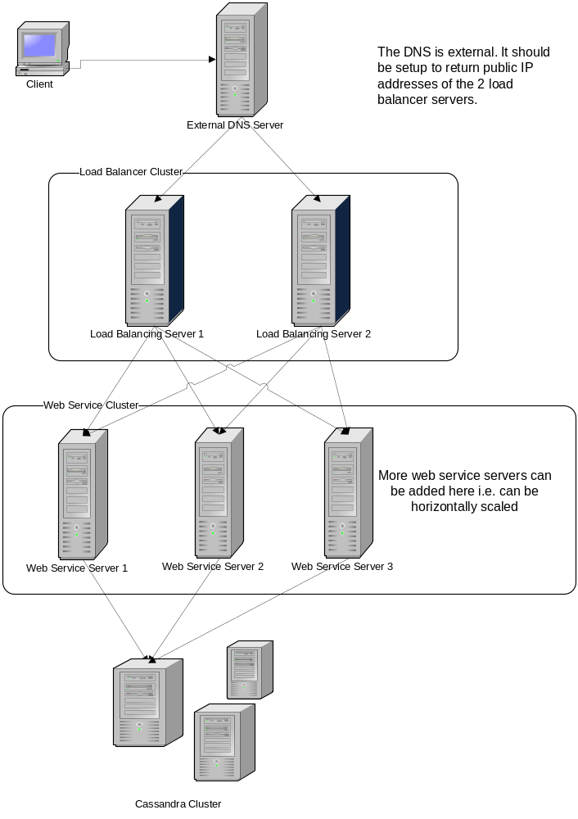
The web server hosting the admin website can simply be one standalone server as it does not expect too much traffic.

The Cassandra cluster, the Zookeeper cluster and the Hadoop cluster will initially actually be the same physical machines. In other words, the same cluster of say 10 computers will be used to host Cassandra, Zookeeper and Hadoop. Initially this setup should suffice and only if memory issues arise, should we move to separate clusters for each.

Physical Deployment

Metrics Requirements
- The application will support 20 to 30 active users (concurrently) performing admin / analysis tasks.
- The Data Collector web service will be designed to scale horizontally, with an initial target of up to 10,000 requests a second.

Page Performance Requirements
- Not known

Hardware
- Cassandra/Hadoop requires ideally at least 4GB RAM
- Multiple Core CPUs are preferred
- 7200RPM hard drives are preferred for Hadoop

Software
- Java 1.6
- Netflix Astyanax – Java client for Cassandra
- Cassandra 1.1.6
- Apache Hadoop 1.1.0
- Apache Zookeeper 3.1.2
- Spring 3.0.x MVC
- FreeMarker 2.3.19
- JavaScript
- Apache Tomcat 7
- Apache HTTP Server 2.4
- Apache CXF 2.7

Database
- Cassandra
- Hadoop

Application Server
- Apache Tomcat 7

Operation Systems
- All nodes (Cassandra/Hadoop/Zookeeper) will run any *nix OS
- The web server node will also run any *nix OS

Prototype conversion
NA

User Interface Implementation
Spring MVC and FreeMarker templates should be used to provide user interface implementation. FreeMarker is preferred over JSP because it does not need to be compiled.

Transaction Management
We don’t need any transactions in the AnalyticsDataCollectorWebService or in the AnalyticsAdminService as the methods consist of at most 1 write to database.

Configuration
The JavaScript module should simply store its configuration in the JavaScript files.
The Server Modules will use properties file for configuration.
The Admin module will use Spring Dependency Injection for configuration.

Logging
See section 5.16

Concurrency and Thread Safety
The AnalyticsDataCollectorWebService will use a separate thread to handle each request. Therefore the code that accesses/writes Cassandra needs to be thread-safe.
The code that runs the data migration from Cassandra to Hadoop will be run from separate nodes. It needs to have code such that concurrent access to the Zookeeper nodes is safe.
The Admin Module Spring MVC controllers need not be thread-safe but the data access classes that access/write to Cassandra need to be thread-safe.

Exception Handling
The AnalyticsDataCollectorWebService will use HTTP error codes to report errors.
The code that runs the data migration from Cassandra to Hadoop will set the status field of the Zookeeper nodes to “Error” and will continuously retry to process them.
The Admin Module Spring MVC controllers will catch exceptions and convert them into appropriate user friendly error messages. In case of unknown errors, a generic error page should be shown.
The JavaScript module needs to log JavaScript errors using the console.log method. Any errors in JavaScript module should not affect the page on which it is running.

